  30 Watt Rd Mornington 3931  5973 6936  www.southerntimberfloors.com | 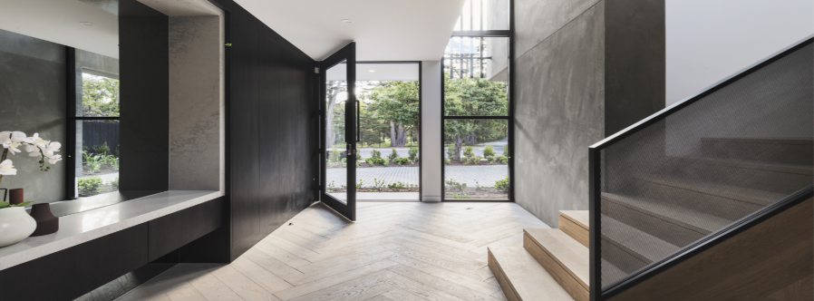

CUSTOMER MAINTENANCE & CARE GUIDELINES

Engineered Pre-Finished Oak & Hickory

Proper maintenance is necessary and a vital requirement to maximise the performance and enjoyment of your flooring investment. A well maintained floor will provide many years of durability and will add to the overall warmth and charm that only a natural flooring product can provide.

If you follow these industry-recognised guidelines, maintaining your flooring will become a simple part of your regular routine. Your flooring retailer can also assist with any enquiries you may have.

General maintenance - how to care for your engineered pre-finished floor.

- Sweep floor regularly with an electrostatic broom, soft bristled broom or wood floor mop.

- Dust and or clean with a soft bristled vacuum head. Ensure vacuum head is non-abrasive with no metal contact points.

- Remove spills promptly with an absorbent cloth or similar. Do not use hard bristled brushes or steel wool scouring pads to clean hard to remove spots or blemishes

- For new installations avoid placing rugs or mats on the floor surface for at least 2 months. This should enable a more even UV exposure to natural and internal lighting. Avoid animal rugs unless you determine the backing is PH neutral or place carpet / rug lining under to avoid bleaching the floor surface.

- Place mats at exterior and interior doors to trap sand and grit from incoming traffic and for drying feet if pool activity is nearby.

- Use a rug or mat in high traffic areas to reduce wear & scuffing. Where possible periodically relocate rugs or large items to allow natural aging of the floor surface area. For new floors please refer to rug and mat details noted above.

- Stick soft pads to the base of all furnishings in contact with the floor.

- When moving heavy furniture or appliances always pick them up rather than sliding across the floor.

- When necessary, clean using a well-wrung mop with warm water and a pH-neutral floor cleaner. We strongly recommend Bona or LOBA floor care products, available for purchase by contacting us directly. Please refer to the manufacturer’s instructions before use

- Do not use supermarket floor or general cleaning solutions as they are likely to be concentrated and if used incorrectly will damage the surface coating.

Your engineered floor is pre-finished with a water-based polyurethane (PU) coating suitable for residential use. If coating repairs or future re-coating are required, please contact us directly to obtain professional advice. Small surface repairs may be possible; however, it is essential to conduct a test application using a compatible water-based PU coating prior to undertaking any in-situ repair. If a leftover floor sample is not available, a small inconspicuous area can be tested, such as inside a cupboard or another less visible location within the room.

Preventative Care.

- Do not steam mop or wet mop floor surface area after installation. Too much water may cause the planks to swell and warp and damage the surface coating.

- Do not use waxes or common household supermarket cleaners or detergents on the floor. These types of cleaning solutions are very abrasive. Long term use will dull the finish and soften the surface coating, reducing its durability and sheen level.

- Chairs with roller wheels must be placed on protective mats to protect the surface coating.

- Do not let sand, dirt or grit build up on the floor surface.

- Avoid walking in narrow point or stiletto heel shoes as they may damage the surface of your floor.

- Do not use masking or other types of adhesive tapes on the surface coating as removal at a later stage may result in coating damage.

- Do not roll or slide heavy furniture or appliances across flooring. Use surface protection or lift trolley to avoid damage.

- Place drip pans or protective matting under pot plants and animal feeding or bedding areas to avoid moisture ingress.

- Importantly, make sure there is a minimum humidity of 35%- 50% in the room. Constant site variations above or below these limits may require the use of a humidifier. Good airflow and ventilation are required to avoid heat and cooling extremes. Long-term exposure may result in changes to the flooring surface. To resolve site specific circumstances please contact us directly for professional advice.

Natural hardwood flooring is photosensitive and will change colour as the floor ages and is exposed to ultraviolet (UV) light. This is a naturally occurring phenomenon and as such these changes are not covered by the product warranty.

Your timber flooring is a long-term investment, and with the right care, it will continue to add warmth, character, and value to your space for years to come.

