  30 Watt Rd Mornington 3931  5973 6936  www.southerntimberfloors.com | 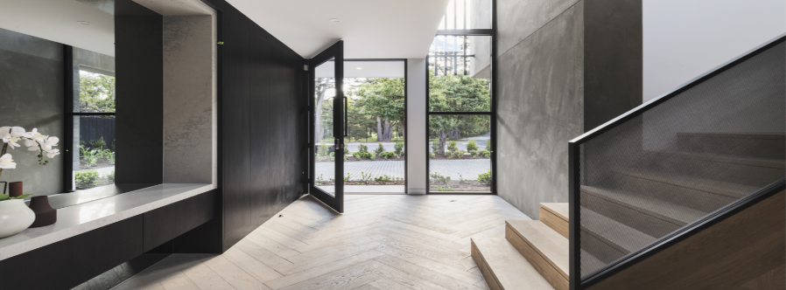

Southern Timber Floors
Hybrid Flooring Fact Sheet

Cleaning and Maintenance Guide

Preventative Maintenance

It is only natural that Hybrid floors will show signs of wear over time. You can expect years of beauty from your floor by observing a few precautions and maintaining regular cleaning and maintenance routines.

- Keep dirt, sand, grit and water off the floor by placing outside mats in front of all entrances to your home.

- Sweep or vacuum regularly to rid the floor of dust and grit that can scratch the finish.

- Remove shoes with spiked or damaged heels before walking on the floor to prevent scratches and dents.

- Keep pets’ claws trimmed, paws clean and free of dirt or soil.

- Always apply felt pads under any furniture or chair legs to prevent scratches and to ease movement. Keep pads clean at all times and regularly check and replace as necessary.

- Protect the floor when moving heavy furniture or large appliances. Place on mat and slide smoothly over floor.

- Never flood the floors or use an excessively wet mop floor with water or any other liquid products. Severe damage may occur that voids the warranty.

- Wipe up spills immediately with damp cloth.

- Exposure to sunlight with its UV rays accelerates oxidation and aging of materials. This may change the colour of the floor. Periodically rearrange the furniture to allow the floor to age evenly.

Cleaning After Installation

- Remove all loose debris from the floor using a vacuum, brush or dust mop

- Ensure that all dry adhesive or wax is removed from the surface.

- Damp mop with a pH neutral detergent.

Routine Maintenance

The cleaning and maintenance regime, whether for commercial or residential homes, is simple and can be carried out by hand or using mechanical cleaning apparatus.

- Spills and tracked-in dirt should be wiped up immediately.

- Periodically, as necessary, thoroughly clean the floor with a good quality spray mop and with a ph neutral cleaner. DO NOT allow excess cleaner to remain on the floor’s surface. Excess liquid may damage both the surface and core of your Hybrid floor.

- Vacuum, sweep or mop to remove all dust and loose debris

- Stubborn stains can be removed by spot cleaning with concentrated ph neutral detergent.

- Never use any of the following products (or similar in nature) on your floor: ammonia-based cleaners, acrylic finishes, wax-based products, bleach, polishes, oil soap, abrasive cleaning soaps, or acidic materials such as vinegar. Many of these products pit or etch the finish of your flooring or prevent the proper use of recommended maintenance materials.

- Use interior and exterior doormats at all entrances to collect dirt and moisture and prevent it from being tracked onto the floor.

- Area rugs are recommended in front of kitchen sinks, at all pivot points within high traffic areas. Do not use rugs with solid rubber or vinyl backings. The rugs must be made of breathable material to prevent moisture entrapment.

- Do not damage your floor with shoes having heel taps or sharp objects protruding from the sole such as rocks, nails or gravel. Avoid walking on wood floors with spike or stiletto heeled shoes. Spike or stiletto high heels must be properly maintained to prevent damage from the steel heel support.

- Do not roll or slide heavy objects directly upon the floor. When moving appliances or heavy furniture, consider laying a solid protective covering on your floor and gently “walk” the item across it. Carpet or cardboard is not adequate to prevent surface compression scratches. Use furniture leg protector pads under all furniture and make certain to keep them clean and well maintained.

- The flooring should be protected with non-rubber matting from damage by casters and wheels on furniture and chairs.

- Protect your floor from direct sunlight. Use curtains and UV resistant film on large glass doors and windows. Colour shade variation can occur if the floor is exposed to direct sunlight.

- The use of any kind of steam mop is strictly prohibited. The use of a steam mop will cause irreparable harm to your floor and void your warranty.

- Radiant heat from fireplaces or heaters should be avoided. Damage can occur.

IMPORTANT:

If any heavy objects such as bookcases, billiard tables, or kitchen units exceeding 200kg per object area, or loads greater than 30kg/cm², are to be installed over the floating floor system, please contact our office to confirm suitability. Failure to seek this advice may result in damage caused by incorrect expansion and restricted raft movement.

