  30 Watt Rd Mornington 3931  5973 6936  www.southerntimberfloors.com | 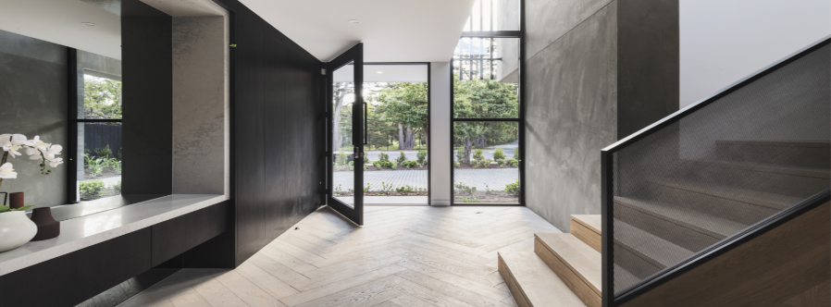
Southern Timber Floors
Timber Flooring Fact Sheet

Timber Flooring is produced from trees.

No two trees are the same.

Therefore, there are no two lengths of flooring that are the same.

Timber flooring is a random, natural blend of colours, grains, and textures.

This is what gives each timber floor its unique beauty.

- Timber flooring is sold based on species (or mixture of species) NOT colour, shade or texture. Variation of colour shade or texture can be extreme in most species.
- Showroom displays are only a guide as to the type of grain and characteristics of that species and should not be relied upon as a perfect match to an entire floor.
- Timber flooring is required to be installed at random, no colour sorting or length sorting should be undertaken, as this would cause a concentration of similar shades in one area thus creating a chess board effect.
- It is impossible to identify the unique features and colour variations a new timber floor will display at the time of installation. These features and colours will become fully apparent after sanding and polishing.
- A new timber floor will darken or lighten depending on the species with time and usage.
- The term ‘select’ grade does not mean that flooring is totally unmarked from gum vein or other markings. It means that it will contain a lower percentage of visible knots or gum veins compared to ‘other grades.’

Installation Facts

- Timber flooring should be installed once all plasterwork is complete, and all windows and external door openings are sealed.
- All sub-floor ventilation should be free from obstacles and all drainage systems should be working correctly to help take water away from the house and sub-floors.
- Timber flooring is kiln dried to Australian Standards which has moisture content between 9% and 14%.
- Timber is ‘hygroscopic’ which means it will take up and release moisture during its lifespan as its environment changes.
- During weather conditions of high humidity, timber will absorb moisture from the surrounding air causing it to swell or increase in size.
- Conversely, during drier times when humidity is low, timber will shrink and reduce in size. Consequently, gapping across a floor can be expected and may be relatively even but the actual gap size between individual boards will vary.
- Wider board widths will move more than narrower boards; therefore, gaps are generally wider and more noticeable. Similarly, during persistent wet weather, high humidity or change in site conditions, floors will tend to expand thus showing fewer gaps and may display minimal cupping.
- Evaporated air conditioning will cause timber flooring to take up and release moisture at much higher levels than normal. Other forms of cooling should be considered.
- Timber flooring should not be stored outside, it should be kept dry and indoors. Storing the flooring in the actual area of installation is Southern Timber Floors specification.
- It is the builders / owner’s responsibility to ensure that all areas exposed to the elements such as external doors and windows are protected once the floor is installed. Moisture and direct sunlight will cause the floor to cup or shrink.
- For sub-floor preparation refer to the Southern Timber Floors specification sheet for any allowances made, i.e. sub-floor sanding, levelling or plywood installation. As most work is quoted and contracted off site plans, Southern Timber Floors reserves the right to alter the contract value base on any extra work required. Sub floors need to be level within+/- 4mm over 2L/M for solid timber flooring installation and 3mm over 3L/M for engineered flooring.
- Installation of timber flooring will be carried out in accordance with the Southern Timber Floors specification sheet, trade certification procedures and manufacturer’s specifications.
- All buildings must be well ventilated during the summer months and well-sealed during the winter months.
- Flooring is supplied in random pack lengths. Overlay flooring (12mm & 14mm thick boards) will vary between 400mm and 2700mm lengths; the average length can be as low as 1400mm. Southern Timber Floors cannot control the length of boards supplied within a pack / order. Sorting of length must not be undertaken as this can affect the appearance of the floor. Boards should be installed randomly, and all packs should be blended.
- EXPANSION JOINTS: Due to the size of houses increasing with open plan living areas 2mm expansion joints are required to be installed on floors with a width exceeding 8 L/M. If the width is close to 8 L/M the installer may remove the need for the expansion joint by increasing the expansion at the wall by undercutting the plaster. If the expansion joint is required, the sander will fill the gap using a flexible caulking colour.

Sanding and Coating Facts and Finishes

- The aim of sanding is to close the grain of the timber to provide a smooth surface for the desired coating to be applied evenly across the floor.
- The contractor working on a new floor can only be expected to even out the floor. Considering the uncontrolled sanding environment, the contractor will not produce a faultless finish using the type of equipment made available. A FINE FURNITURE FINISH SHOULD NOT BE EXPECTED. A minimal level of minor sanding marks, fine scratches and nail holes may be visible. The work will be completed to the best possible standard.
- All top nails and natural imperfections will be filled with putty or caulk. Due to colour variations in timber, it is expected that a putty or caulk of average shade is used across the whole floor.
- Floors with a high gloss finish will magnify imperfections. Down lights or streams of natural light can also highlight minor sanding marks.
- Most dust and surface imperfections in the coating will wear away within a few months under day-to-day foot traffic. Floor finishes will not prevent timber movement.
- Floor finishes will not significantly improve the hardness of timber flooring. Timber flooring can be expected to show some indentations depending on the hardness of species installed.
- Hardness of timber density, measured by Janka rating, indicates a species resistance to indentation. The higher the rating means the more resistant the timber is to indentations.
- Water based polyurethane finishes offer many benefits. They are UV stable, minimise edge bonding and maintain the natural colour of the timber. They are non-toxic and fast drying and are less shiny than solvent based polyurethane finishes. Loba is the product used by Southern Timber Floors, which is available in Semi-Gloss or Matt/ Satin.
- Fiddes Hard Wax Oil is a 2-coat floor coating system. This product is fully cured after 7 days from the application of the final coat. It is non-toxic, highly durable, non-yellowing and able to be used on stair treads with a slip rating of R11. Available in Matt, Silk, Satin, and Gloss.

Caring for your Timber Floor

- Allow 36 to 48 hours before moving furniture onto the finished floor
- Apply felt pads to the base of all furniture to avoid excessive scratching.
- Allow 14 days for solvent based and water-based finishes to fully cure
- Place mats at entrances, both internally and externally. They collect dirt and grit. 3M research concluded that 50% of grit can be reduced from a floor with just 2 meters of matting at entrances.
- Use a soft, dry electrostatic mop frequently to keep the floor free of dust, dirt, and grit.
- Do NOT use steam mops, all guarantees will be void.
- Wipe up all spills immediately.
- Clean your floors with a suitable mop and the recommended cleaners or warm water or a Ph neutral cleaner specifically designed for floors. Ensure the mop is well wrung and only slightly damp. Do NOT saturate floor with water.
- Do not use any silicon or oil containing cleaning products.
- Do not have your heater running at extreme temperatures for long periods.
- On hot days, close your window furnishings to minimise intense heat from UV exposure to the floor. Ensure your home is well ventilated during periods of hot weather.
- During dry summer months if homes are left vacant, Southern Timber Floors recommend buckets or vases of water with spill trays be placed around the floor to maintain moisture in the atmosphere.
- Ducted heating vents should be plastic to reduce the chance of gapping around heating ducts.

Please Ensure the Following

- Please do not lay carpets before sanding and coating. This will increase dust particles in the air and affect the coating appearance.
- Do not apply the final coat of paint to walls or skirting boards prior to completion of works. Southern Timber Floors accepts no responsibility for damage to the above.
- Instruct painters to use drop sheets on flooring works.
- Instruct cleaners and other trades to not saturate floor with water.
- Ensure that no other trades are allowed on to the property at time of flooring works, especially during the sanding and coating process or for 36-48 hours after the final coat has been applied.
- Ensure all windows, doors, air vents and fireplaces are sealed and protected from rain and wind blowing in dirt and grit and that external drainage is working and maintained. Remove all furniture, window furnishings, food, paintings, and clothing away from site.
- Arrange alternative accommodation during coating times, especially if using solvent-based polyurethane and alcohol-based coatings to avoid exposure to toxic vapours.
- Gas appliances should be turned off at the mains and all naked flames extinguished.
- Remove dishwashers and connected ovens prior to beginning the flooring work.
- Do not use heating and cooling appliances during coating times.
- Do not use any harsh brooms or detergents on finished floors.
- Window coverings must be used to help protect the floor from exposure to direct sunlight to reduce the heat generated by windows drying out the timber and causing gapping and cupping.
- Humidity levels in the home should be always maintained between 45-60%.

This document has been produced for the benefit and education of Southern Timber Floors Customers for an accurate expectation of their new timber floor. Timber Flooring is one of the world’s most beautiful, warm, and interesting floor coverings and is truly timeless. Southern Timber Floors’ commitment to each client is to deliver the best possible result and to inform clients with a clear level of understanding and expectation about timber flooring.

The Client has read and understood the Southern Timber Floors Fact Sheet and has received a copy for their records.

Name: Signature: Date:

